Hyperallergic
Raven Chacon
November 25, 2024
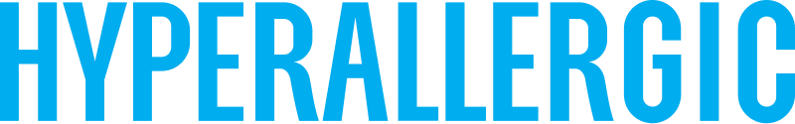

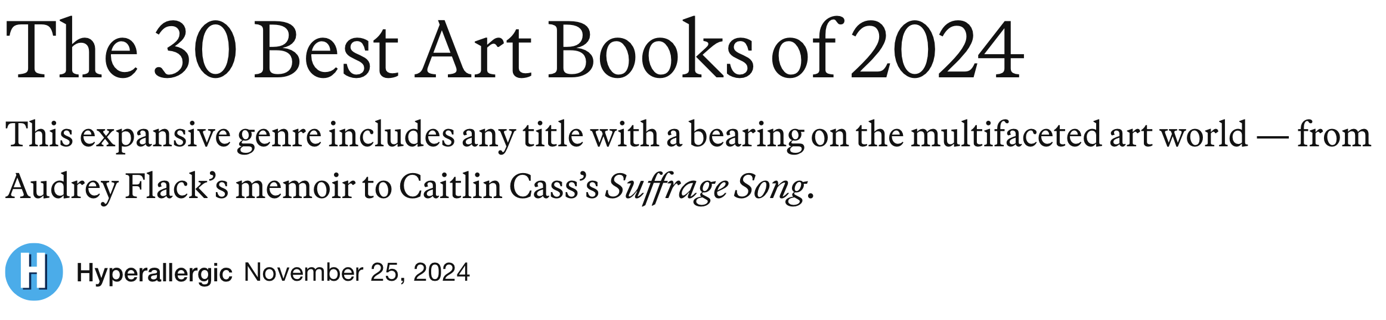
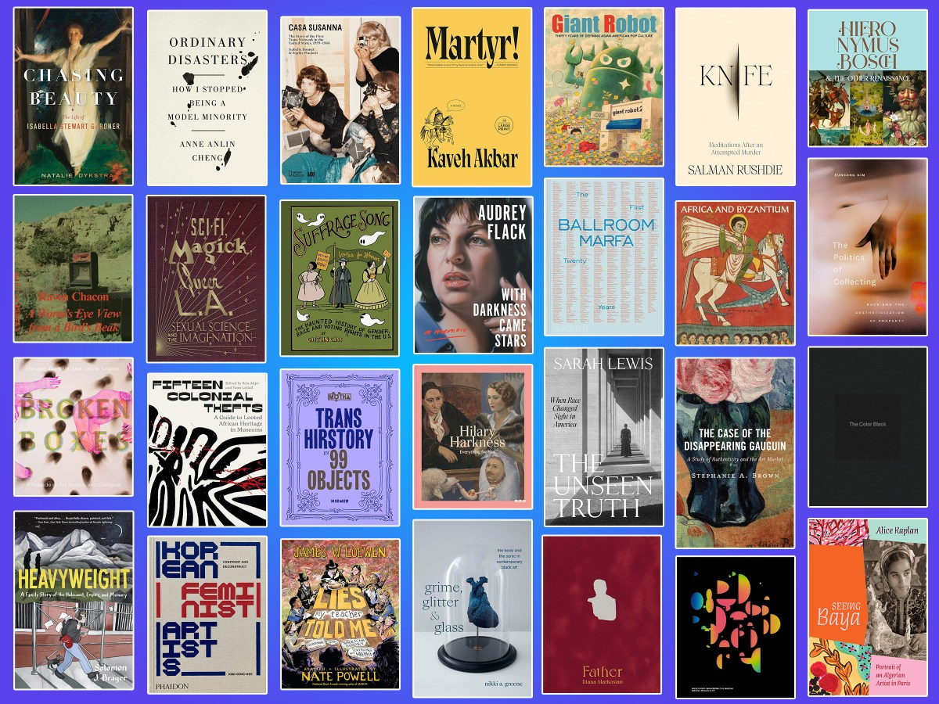
What were your favorite art books of 2024? (edit Shari Flores/Hyperallergic)

We’re proud to present our list of the best art books of 2024 for your holiday reading, and perhaps to inspire your gifting this winter. Our editors and critics read across genre, subject, and place this year, from memoirs and graphic novels to catalogs, artist books, and everything in between. Hyperallergic Editor-in-Chief Hrag Vartanian muses on the poignant work of photographer Diana Markosian in Father, while critic Alexandra M. Thomas recommends Nikki A. Greene’s book reframing the study of Black visual art and musical production. Read on for Reviews Editor Natalie Haddad on Trans Hirstory in 99 Objects, Associate Editor Lisa Yin Zhang on scholar Anne Anling Cheng’s essay collection, my love of Audrey Flack’s memoir, and more ordered by publication date in the list below. As always, we approach the “art book” category with flexibility, considering titles that seam the art world with its incalculable intersections with other fields. Let us know what your top books of 2024 are, and happy reading! —Lakshmi Rivera Amin, Associate Editor

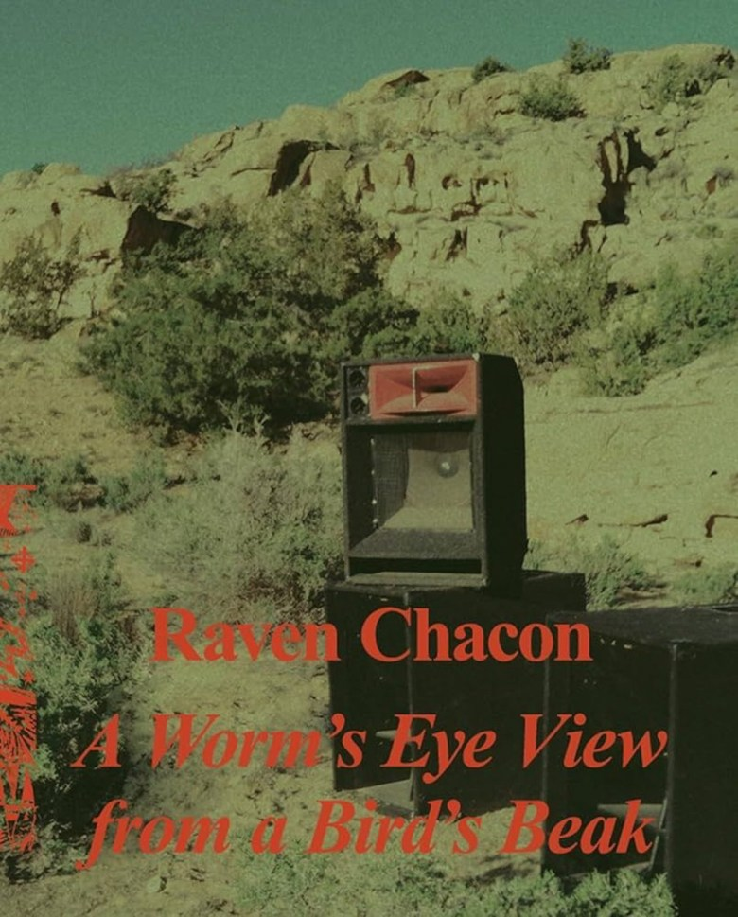
Raven Chacon: A Worm’s Eye View from a Bird’s Beak, edited by Alison Coplan, Katya Garcia-Anton, and Stefanie Hessler
Sometimes a book about an artist and their work strikes a chord. So it was for me with Raven Chacon: A Worm’s Eye View from a Bird’s Beak. Considering Chacon’s sophisticated, multidimensional relationship with sound, whether noise music or chamber music or something altogether undefinable, this pun might feel trite. But with contributions from writer and critic Aruna D’Souza, Sámi filmmaker and reindeer herder Marja Bål Nango, poet Sigbjørn Skåden, curator Candice Hopkins (Carcross/Tagish First Nation), and others — plus a lexicon of Chacon’s musical notations — this book resonates with an energy similar to that of the Diné artist’s deeply relational, highly collaborative practice. Published in conjunction with his traveling solo exhibition at the Swiss Institute in New York and Nordnorsk Kunstmuseum in Northern Norway/Sápmi, the monograph guides readers through the sites and sounds of Chacon’s career, from 1990 to 2023, and draws connections between the survivance of Navajo and Sámi peoples who share Indigenous histories that colonialism has attempted to annihilate. The book acts much like one of Chacon’s scores, offering a structure for improvisation. To quote John Cage, begin anywhere. Correction: Begin where you are. —Nancy Zastudil
Buy on Bookshop | Swiss Institute, Nordnorsk Kunstmuseum, and Sternberg Press, February 2024

